ePass Management System

Hands on Document |  | Feb 12, 2014

Revision History

Date | Version | Description | Author
12-Feb-2014 | 1.0 | Hands on Document | Sonali Nayak
09-Sep-2016 | 1.1 | Revised document | Satyajit Shadangi

Secretariat Pass Management
Online
Hands On Document

Purpose
The Secretariat Pass is issued for the purpose of important meeting and discussion of the outside visitors with the different department officials of the Secretariat. To enter into the Secretariat campus, the visitor needs to be authorized and hold a pass issued by the concerned pass issuing reception counter. The Secretariat pass issue process is managed by the Home Department. There are two types of pass- Daily and Seven Days. The pass is issued only when the visitor provides his identification proof (like PAN card, Ration card, etc.

- To start using the Online Secretariat Pass application, enter the url in the browser to view the login screen-
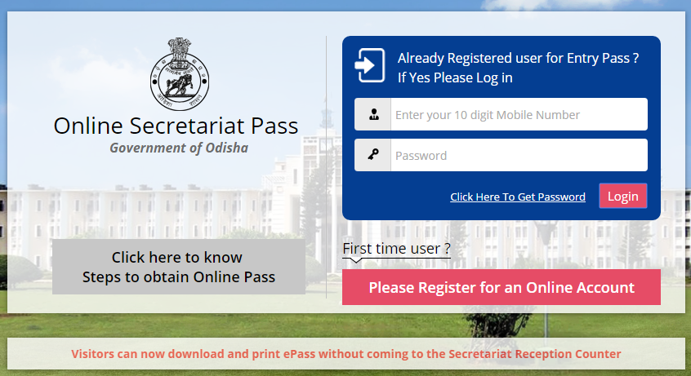
- In the Login screen, to know the procedure for applying for the ePass, click the Steps for ePass link as highlighted above.
  - The following pop-up screen is displayed-
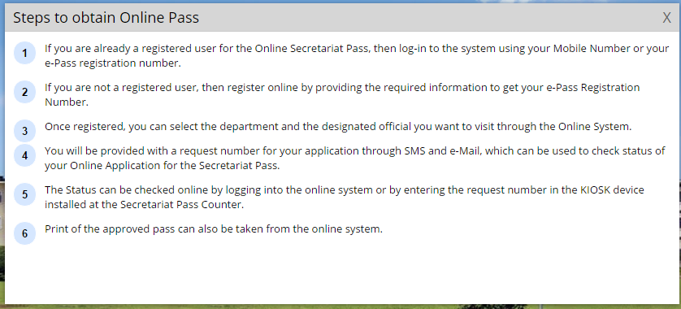
  - After going through the guidelines, click the cross symbol to close the page
- In case a new user, click the Register button-
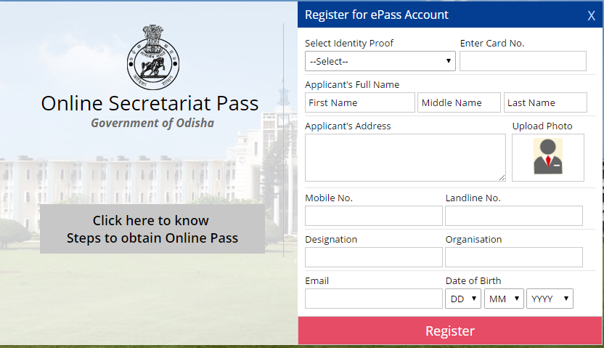
  - In the Register for ePass Account screen displayed-
    - Select the Identity Proof held by the applicant.
    - Enter the Card No. of the identity proof.
    - Enter the Applicant’s Full Name in the First Name, Middle Name and Last Name textboxes provided.
    - Enter the Applicant’s Address.
    - Click the Upload Photo to upload the applicant’s photograph.
    - Enter the applicant’s Mobile No.
    - Enter the applicant’s Landline No.
    - Enter the applicant’s Designation.
    - Enter the Organization name where the applicant works.
    - Enter the applicant’s Email Id.
    - Select the applicant’s Date of Birth from the drop down list.
    - Click the Register button to finish registration.
      - An unique identification number is generated.
- If the user already has an ePass Account, then back in the login screen-
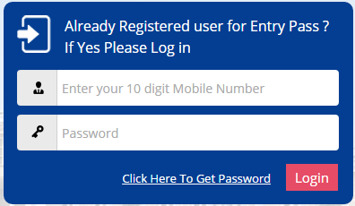
  - Enter the registered Phone Number in the textbox.
  - Enter the password received on Mobile after registration.
  - In case user has forgot his/her password click on "Click Here to Get Password" to receive new password in registered mobile.
  - Click the Login button.
- The Apply e-Pass is the default page-
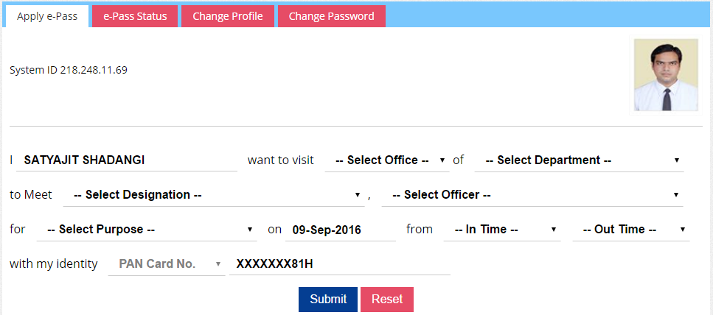
- In the applicant’s welcome page, the user has to fill-in the following details-
  - The name of the applicant remains default.
  - Select the Office Name from the drop down list.
  - Select the Department name from the drop down list.
  - Select the Designation name of the officer.
  - Select the Officer name from the drop down list.
  - Select the Purpose of visit from the drop down list.
  - Select the visit In Time and Out Time from the drop down list.
  - The Identity proof no. is displayed.
  - The photograph of the applicant is also displayed.
  - Click the Submit button.
- Click the e-Pass Status button to view the visit details of the applicant on a daily basis-
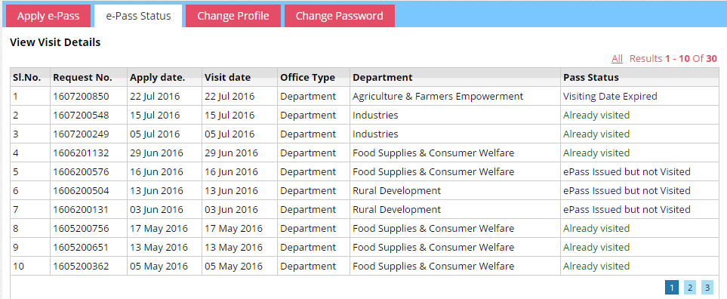
  - The status of the passes issued on different dates is displayed along with the Request No. of each.
- To edit the applicant profile details, click the Change Profile button.
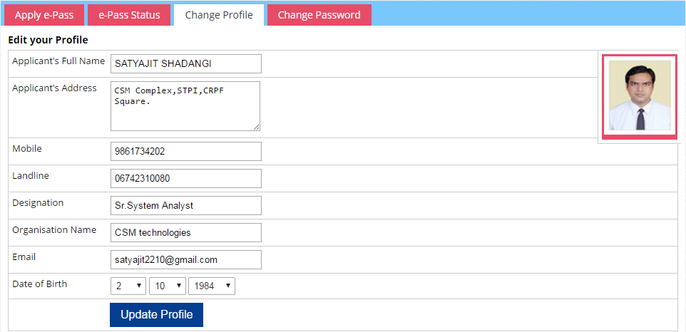
  - The profile details as already entered is displayed.
  - Enter the new data in the respective fields.
  - Click the Update Profile button to save the data modified.

- To change password ,click on Change Password button.
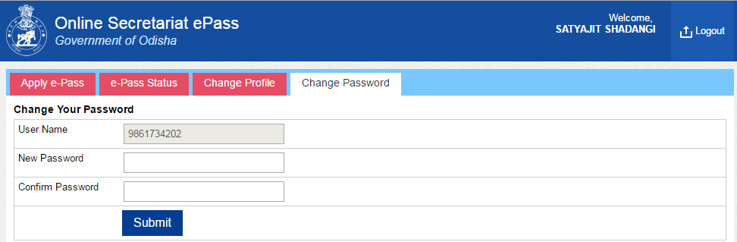

  - Enter New Password.
  - Enter Confirm Password.
  - Click the Submit button to change the password.
  - The new password will be received on mobile.

- Click the Logout option to move out of the applicant’s account.

